Setup minikube at your local and explore creating namespaces (Go through official documentation).

Minikube:
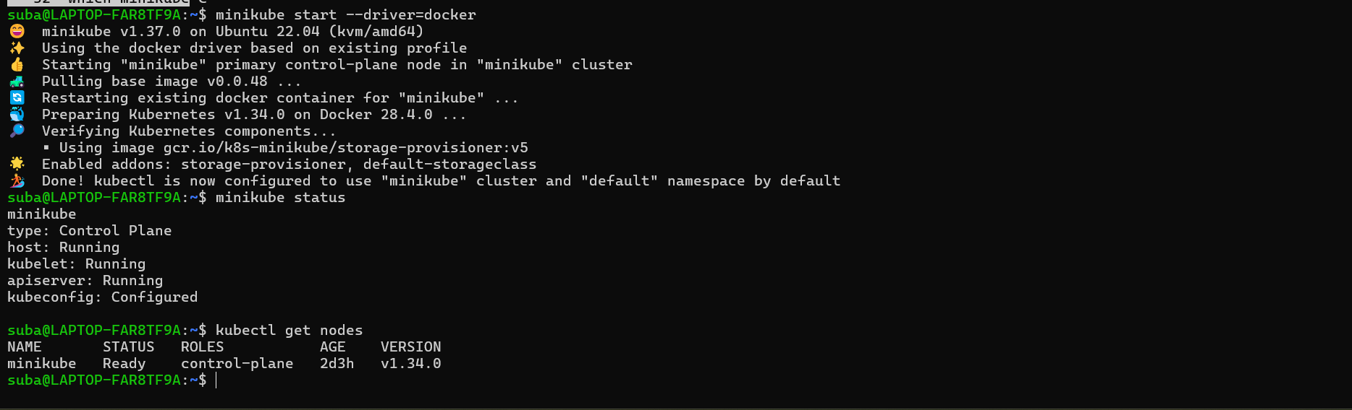
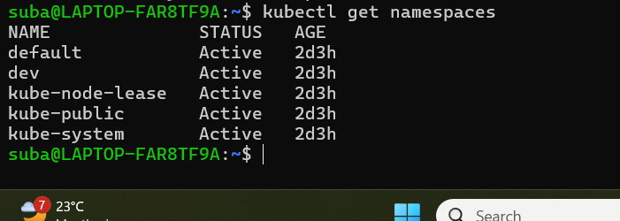
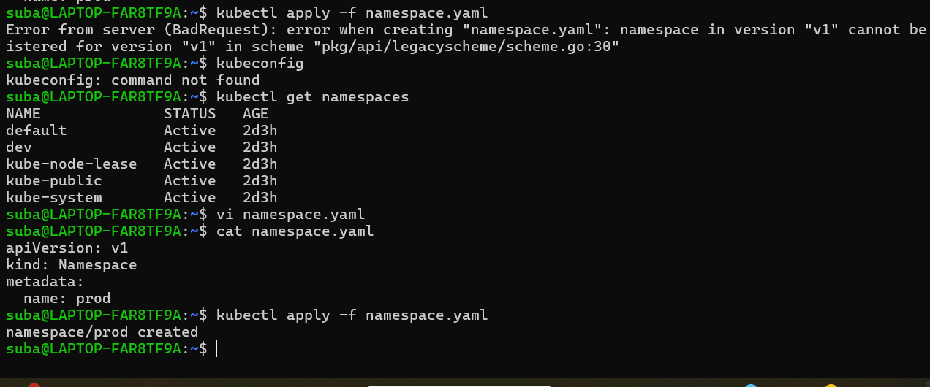
Minikube creation:
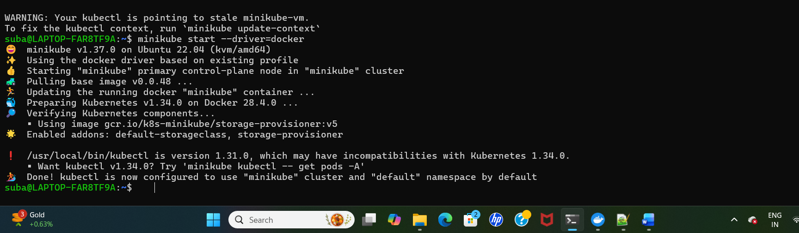

Default name space:
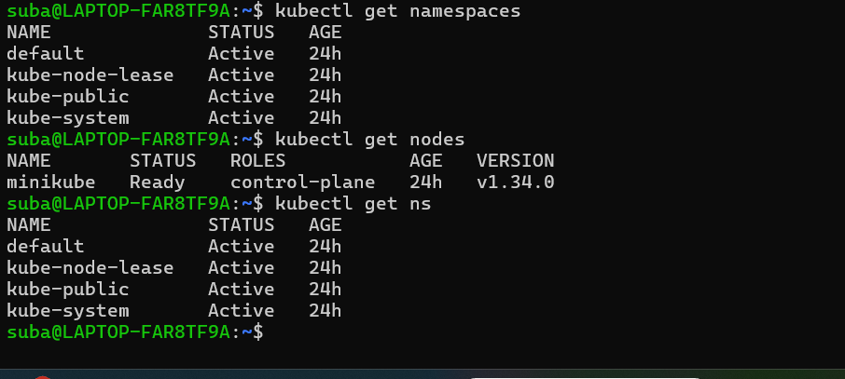

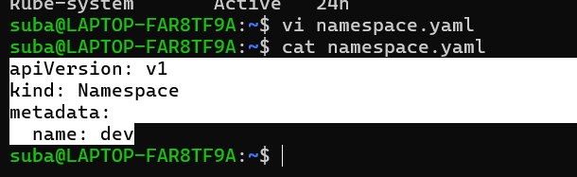

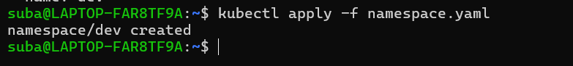
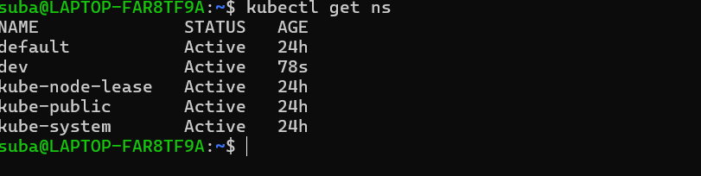
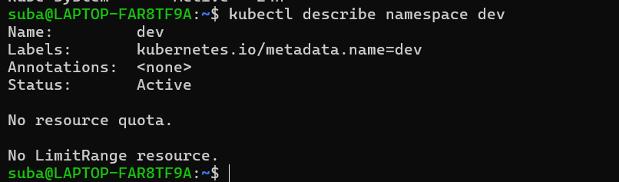

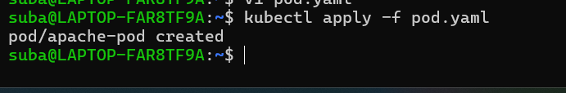

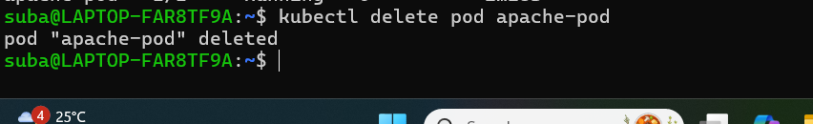

Now I want to apply this pod in specific namespace:
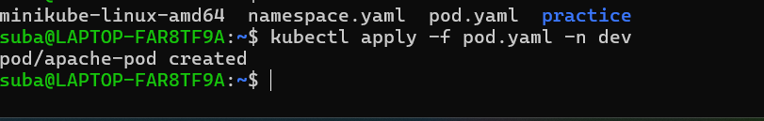
My pod is running inside the name space:
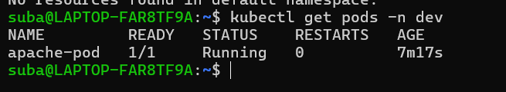

Have created a pod resource in dev namespace in yaml file:
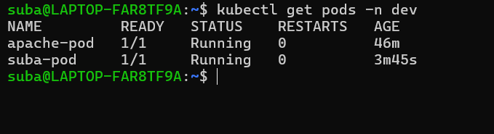

apiVersion: v1
kind: Pod
metadata:
name: suba-pod
namespace: dev
spec:
containers:
- name: nginx
image: nginx
ports:
- containerPort: 80
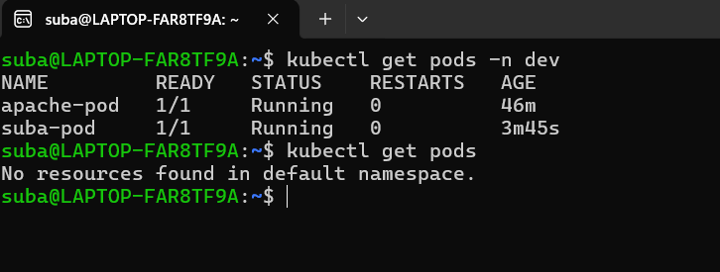
Replicaset tried in default name space:

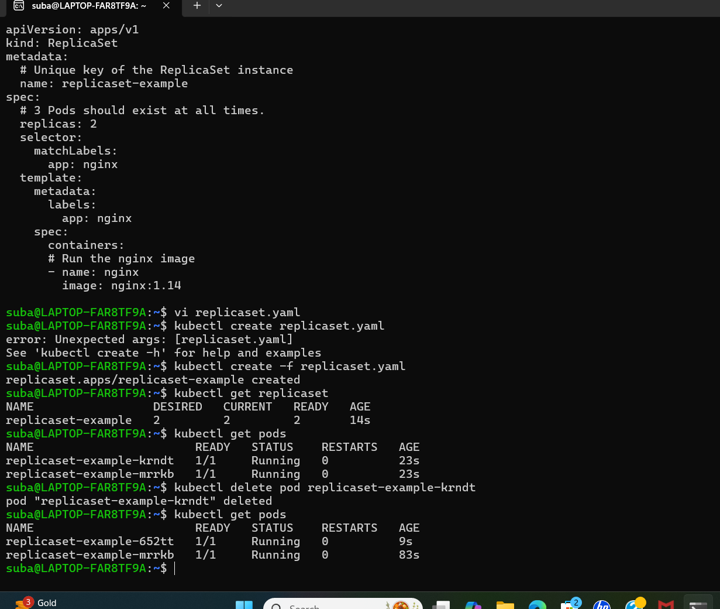

Tried mentor task:

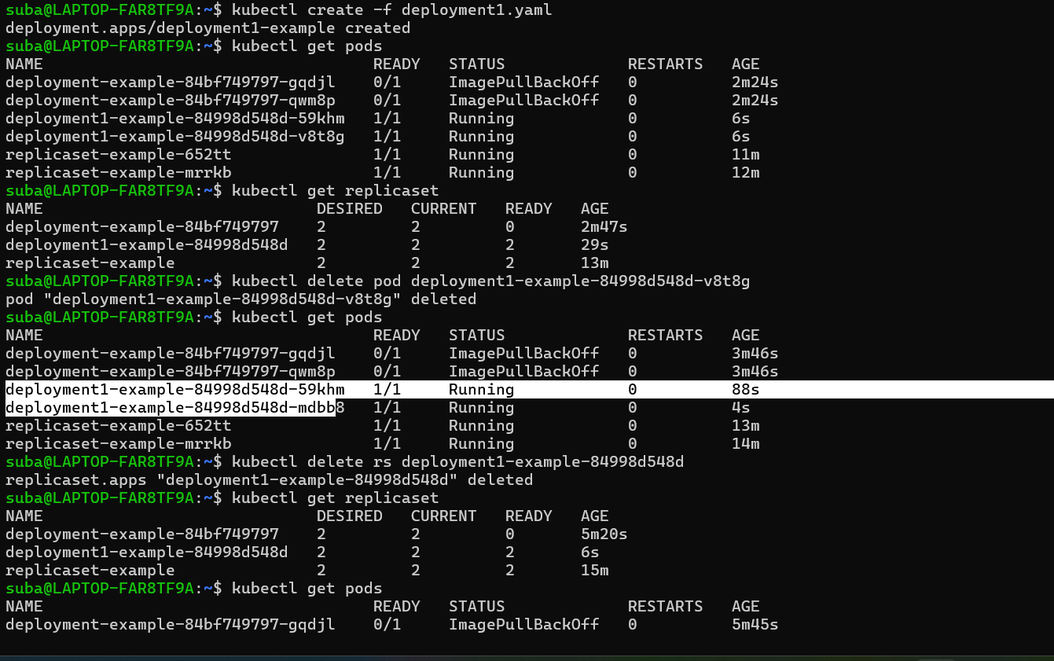

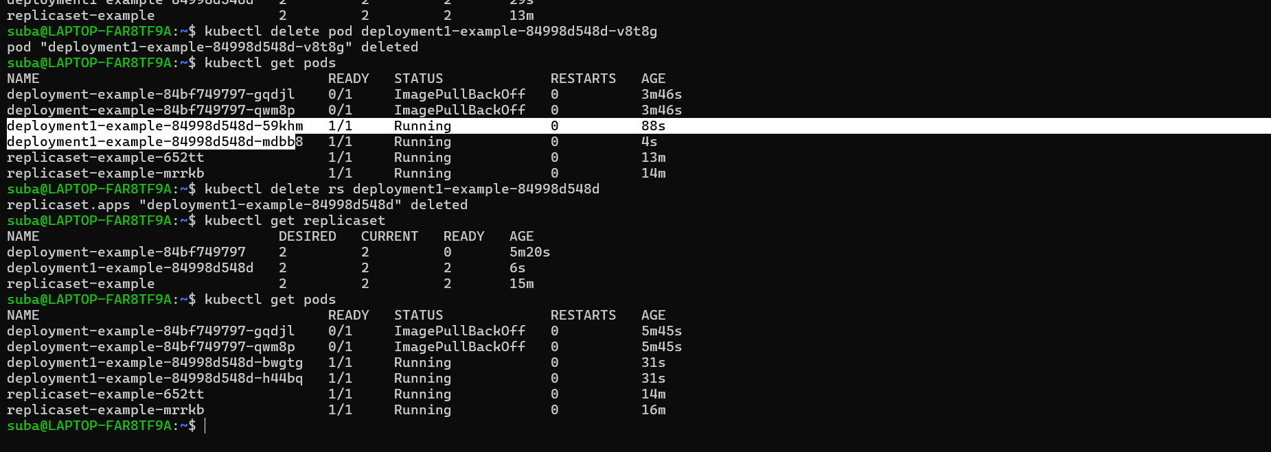

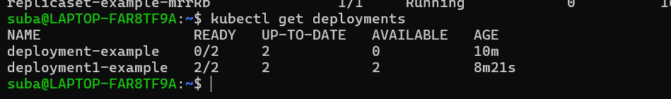
the advantage of using deployment is, replicaset will come by default;

